Task 4: Handle multiple beans implementations using @Autowired with @Qualifier to resolve ambiguity. Create an
interface NotificationService. Create two implementations: EmailNotificationService, SMSNotificationService.
STEP 1: Create Spring Boot Project
In Eclipse:
- File → New → Spring Starter Project
- Fill details:
Field | Value
Name | NotificationApp
Type | Maven
Packaging | Jar
Java Version | 17 (or your installed version)
Group | com.example
Artifact | notificationapp
- Click Next
- Add dependency:
  - ✅ Spring Web
- Click Finish
Project Structure Image:
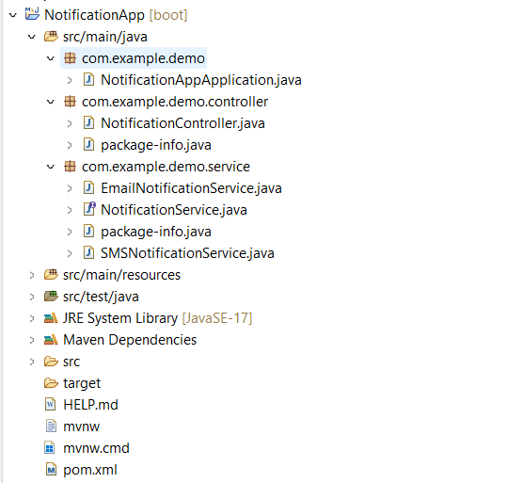

STEP 2: Create Interface
service → NotificationService.java
package com.example.demo.service;
public interface NotificationService {
String sendNotification(String message);
}
STEP 3: Create Email Implementation
service → EmailNotificationService.java
package com.example.demo.service;

import org.springframework.stereotype.Service;
@Service("emailService")
public class EmailNotificationService implements NotificationService {
@Override
public String sendNotification(String message) {
return "Email Sent: " + message;
}
}
STEP 4: Create SMS Implementation
service → SMSNotificationService.java
package com.example.demo.service;
import org.springframework.stereotype.Service;
@Service("smsService")
public class SMSNotificationService implements NotificationService {
@Override
public String sendNotification(String message) {
return "SMS Sent: " + message;
}
}
STEP 5: Create Controller
controller → NotificationController.java
package com.example.demo.controller;

import org.springframework.beans.factory.annotation.Autowired;
import org.springframework.beans.factory.annotation.Qualifier;
import org.springframework.web.bind.annotation.*;
import com.example.demo.service.NotificationService;
@RestController
@RequestMapping("/notify")
public class NotificationController {
@Autowired
@Qualifier("emailService")
private NotificationService emailNotification;
@Autowired
@Qualifier("smsService")
private NotificationService smsNotification;
@GetMapping("/email")
public String sendEmail(@RequestParam String message) {
return emailNotification.sendNotification(message);
}
@GetMapping("/sms")
public String sendSMS(@RequestParam String message) {
return smsNotification.sendNotification(message);
}
}

STEP 6: Main Class
NotificationAppApplication.java
package com.example.demo;
import org.springframework.boot.SpringApplication;
import org.springframework.boot.autoconfigure.SpringBootApplication;
@SpringBootApplication
public class NotificationAppApplication {
public static void main(String[] args) {
SpringApplication.run(NotificationAppApplication.class, args);
}
}

STEP 7: Run Application
- Right click project
- Run As → Spring Boot App
Tomcat started on port(s): 8080
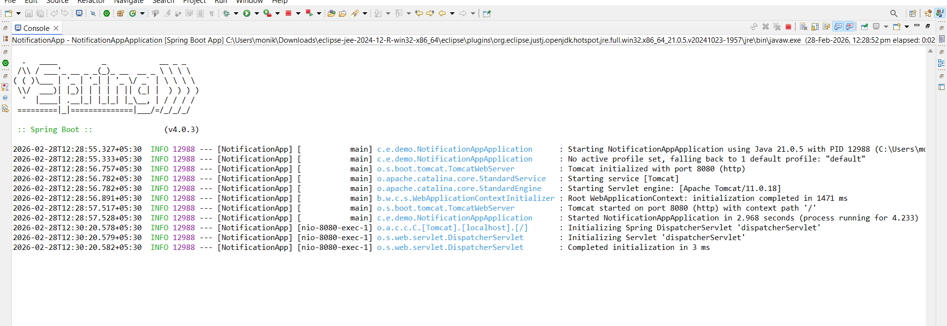

STEP 8: Test in Browser / Postman
http://localhost:8080/notify/email?message=Hello
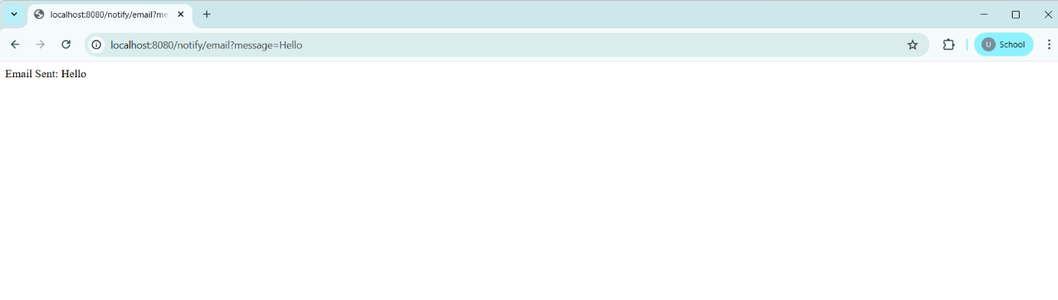
Send SMS
http://localhost:8080/notify/sms?message=Hi
